**­­**

**Results: Community Energy Explorer Interviews**

*Collaborative for Advanced Landscape Planning*

*University of British Columbia*

Submitted to:

The Real Estate Foundation of British Columbia

Metro Vancouver

**Executive Summary**

The Community Energy Explorer (CEE) is a free online web resource, designed to help municipalities and citizens think about and plan for energy in their communities. As an existing web platform, our funders from Metro Vancouver and the Real Estate Foundation of British Columbia requested to revise and evolve the website to include more tangible products to be available to a variety of users. This required requesting and soliciting feedback through interviews from various sectors relating to community energy and planning.

The results identified key items summarized below:

* The website provides good information and visuals for general public and non-expert local government as an educational resource (“community energy 101”)
* Need to define the process from start-to-finish on identified energy topics (how to use this info)
* Need to offer clear content for energy experts and non-experts through downloadable guides, tools, and resources for audience members to use for their communities
* Identify opportunities for content, engagement, and social media to become a community energy hub (strategy for audience to revisit back to the website)

In response to these items, the website will undergo changes in the userface and interactivity that were also mentioned in the interviews for the better usability. The interviews included members from the public, private, and not-for-profit sectors for inclusion and diversity of various community energy and planning work.

The responses were recorded and synthesized by the Planning & Policy Analyst at the Collaborative for Advanced Landscape Planning (CALP) lab to provide to funders an interim update in June 2017 and final reporting for October 2017. This document summarizes results of the interviews, with privacy protected for the members interviewed in this process.

For any inquiries, questions and/or concerns, please feel free to contact Kai Okazaki at [kai.okazaki@ubc.ca](mailto:kai.okazaki@ubc.ca) for further discussion.

**Introduction**

Overview

The Community Energy Explorer (CEE) website is being updated to provide a current and relevant version of a community energy planning tool. The initial step was to solicit feedback from various sectors relating to community energy and planning. This was done by contacting members of the public, private and not-for-profit sectors to be interviewed either in-person or by phone conversation. Participants were asked a series of questions that focused on their user experience with the website, what value the website brought, and what areas of opportunities (and potentials) the website could have based on their needs in their workplace. This report provides a brief synopsis of the results of the interviews, focusing on what we heard and the validation and direction on where the website will go by the end of the project in September, 2017.

Objective

The objective is to identify more specifically the CEE’s target audience and structure how the narrative will speak to various users through visuals – **What is unique; what is needed and what is useful?**

**Results**

Participants & Target Audience/Users

In total, 16 people were interviewed to review, provide input and feedback to the current CEE (Figure 1). The participants were given the website link, and two scenarios (See Appendix - West Vancouver CEEP; Richmond Mall Infill). There was more emphasis on interviewing the public sector as the main users of this website (municipalities and citizens). Therefore, half of the interview respondents were from municipalities, crown corporations, and institutions.

****

Figure 1: Demographic of interviewees and their employment sector - refer to Appendix A for the complete list (credit: Kai Okazaki)

Flowchart

Secondary Audience

Primary Audience

Direct Engagement

Indirect Engagement

**Website**

**Usage**

**Users**

Own Use (Limited)

Mediated Engagement with the public

Other City Staff including Planners

City Staff- Energy Managers

(experts)

City Councillors

Community Energy Explorer

Teachers & Educators

Developers & Industry

Public Stakeholders & Citizens

Figure 2: Flowchart of the Community Energy Explorer through various audience members (credit: Kai Okazaki)

In Figure 2, the interviews described who interviewees were working with in their respective roles and who their work influenced. As a result, many of the energy managers engaged with the website for their own use, but also described their mediated engagement with councilors & others. Planners would also follow a similar pattern of indirect engagement, either through energy managers or sustainability-focused. City Councillors are an important demographic to engage as the ultimate decision-makers for community energy work within their municipalities. The more confidence provided by staff, the better and more informed decisions that can be made by Council.

Target Audience

Table 1: Target audience identified through experts and non-experts in community energy content

|  |  |  |
| --- | --- | --- |
| **Audience** | **Energy Experts** | **Energy Non-Experts** |
| Primary | * Energy Managers, Planners (Sustainability-focused) | * Planners, Councillors, Homeowners, Energy Enthusiasts |
| Secondary | * Developers, Architects, Construction, Real Estate, Engineers, Finance | * Teachers, Educators, Building Managers |

Within our primary and secondary audience, there were both energy experts and non-experts identified for the interviews (Table 1). The primary experts included energy managers and planners (energy-related) and their associated (secondary) audience that they work with. The primary non-experts included planners (non-energy related), Councillors, homeowners, and energy enthusiasts, with a secondary level of teachers, educators, and building managers as potential users and how they can navigate the website.

**Recommendations**

Current CEE Website

**CEE already doing well:**

1. Provides good information and visuals for general public and non-expert local government as educational resource (“community energy 101”)

**Opportunities for improvement:**

1. If CEE is to receive more engagement and use from energy managers, decision-makers, etc. to use for informing local government policies, then the website needs to provide more content relating to the “experts”
2. Add specific ways to use the data (how do you go from start to finish?); Define the user’s process
3. Offer tools, programs, and resources for audience members to use in their communities (for CEE to potentially become a hub)
4. Engage in ways that will keep people coming back to the website over the long-term (e.g. social media plan, newsfeed, email directory, new content, forum, tied hashtag (#) etc.)

Action Items

1. Redesigning the website to consider experts’ and non-experts’ preferred formats
2. Restructure the website for easier user interactions
3. Clearly identifying on website what people are able to take away from it
   1. Experts with content and information about their surrounding municipalities (e.g. links to CEEP-related reports, policies, plans, etc.)
   2. Non-experts with resource and guides about their actions towards community energy (i.e. teachers guide, neighbourhood coolkit, etc.)[[1]](#footnote-1)
4. Adding more case studies as examples that can be done in any municipality
5. Defining the scope of the energy maps to alleviate any ambiguity or confusion
6. Aim to be the “Community Energy” Information Hub for Metro Vancouver[[2]](#footnote-2)
   1. Downloadable graphics?
   2. Media presence (needing further discussion)
7. Identifying the list of specific things they told us to fix in existing CEE (what to keep/liked/fix/change/remove)

Other Items raised

1. Long-term hosting and CALP’s role after the project is completed?
2. What is Metro Van/REFBC’s role after the project is completed? In other words, how will the website be sustained?
3. Recommendations/list of action items that should be continued with more funding (Citizen science, Thermal imaging, etc.)

**Responses from Public Sector Staff (N=8)**

**In your role, what kind of projects do you work on that are related to community energy?**

* Energy Step Code for Buildings (New development/construction of buildings)
* Electric vehicles (electrification)
* Building energy benchmarking (comparing with other municipalities)
* Energy policy writing to planners and council
* Community Energy programs out to citizens and industry (more emphasis on industry)
* Ensure alignment with CEEP and OCP targets

**Who do you work with in your team? Who is your target audience?**

Team:

* Various members for team, dependent on department and staff capacity (i.e. some are in planning department, some are in other department; staff number are different in each municipality)

Target audience:

* **In-house staff**: managers in planning, transportation, facilities, community development, councilors or elected officials, engineers,
* **Buildings**: developers, real estate, construction, property managers, property owners, strata councils, investment firms
* **Electric Vehicles**: automobile sellers, customers, developers, constructions/engineers
* **Retrofit**: homeowners, commercial/industrial properties
* **Public**: Some general public (not much direct engagement)

**What are some challenges you face and what projects need more support? Is it implementation? Convincing council?**

Challenges:

* **Interaction with Council**: Council generally supportive of Community Energy & Emissions Plan (CEEP) work (so long as it aligns with government targets); some CEEPs have been adapted; and in other cases, cities are still able to advance projects that staff put forward (i.e. built out of municipality’s OCP). Some staff do not directly interact with Council and have other planners or members represent energy issues.
* **Convincing and Support:** Some convincing and support needed with staff still learning about community energy work; how to sell or convince operations staff or related-departmental staff
* **Capacity**: Limited capacity to do the work Community Energy Managers (CEMs) have much work underway, the number of staff working; council prioritizes on what gets done, and what gets pushed aside
* **Finance:** Funding cycle and budgets – finding the capacity to do the work
* **Time and scope**: CEM work schedule
* **Interests**: What are BC Hydro’s interest and how can they work with CEMs; PowerSmart has shifted from energy conservation and efficiency DSM to capacity-focused broader energy management and low-carbon electrification EV; work with large consumers on managing capacity on the electric grid – what are the opportunities)

**Where do you look for your information and sources for community energy work?**

* No one hub of information is available for all CEMs
* Community Energy & Emissions Inventory (CEEI)
* BC Hydro online portal website (internal)
* Local government’s departmental data
* Census and Canadian Household Survey (dwellings)
* Existing websites on BC CEA, BC SEA
* Calling, emailing and chatting with other CEMs
* Monthly or Quarterly workshops hosted by BC Hydro (roundtables)
* Webinars
* Independent research
* BC Hydro has a tool that was developed by the CEMs – Community energy management assessment tool, module focused on process rather than the tool, looking at ways for BC Hydro to facilitate local government having a CEM or renewing a CEM conversation (green buildings, EV, benchmark priorities, and future modules coming in place) to reflect local government progress, benchmark, and develop a work plan to achieve goals for municipalities
  + Flexible for each CEM to be able to achieve deliverables dependent on where the progress of municipalities, and identify the gaps to strengthen within their scope

**We are currently changing the CEE website to curate different sections? Do you have any suggestions for how this information can best serve your needs?**

* Aides BC Energy Step Code[[3]](#footnote-3)
* Energy benchmarking work (pulling up quick data and information for fact checking and internal comparison)
* Ways to show side-by-side comparison with other municipalities on their community energy work
* Create a hub/community where plethora of public raw data can be used in different ways
* Toolbox analogy to give staff access to your resources on-demand
* Providing resources to tailor different levels of literacy for staff (expert/non-expert) – community energy 101 for local government and public; room for higher-level detail and info for more experts
  + Show difference between corporate and community energy[[4]](#footnote-4)
* Attempt focus group style (info package) by generating discussion or consensus among group on what kinds of resources may be needed (i.e. CEM, homeowners, developers, etc.)
* Can the materials be easy downloaded e.g. - infographics that staff can use for communication?[[5]](#footnote-5)
* 2.0 of the website elevated to communicate technical facts of doing vs. not doing the actions, what are the savings people or communities can get, co-benefits (better livability)[[6]](#footnote-6)
  + 3.0 (future) component to show what action plans would look like – e.g. pilot projects out at UBC for building energy performance and what that looks like (potential in tying it to energy step code; going to council, getting consensus of pilot success)

**Do you use and look at the existing CEE maps, case studies, resources, tools, etc.?**

* Host a workshop on what CEMs and local staff & councilors want as case studies/maps, etc.
* Most replied that they haven't seen the case studies until sending it to them
* Case studies are useful by including specific targets (i.e. step code, cost targets, etc.)
* Maps will be useful with more precise information on data showed in & modelled in mapping (i.e. energy demand map confusing; driven by lot or house size?)
* Map showing energy use and scenarios to help with benchmark standard set of energy data for one building (my climate, my neighbourhood model)
* Map with model and actual savings on energy over time
* Renewable energy mapping – interested in seeing from policy-stand point to make resources available in detailed report and how it was done (implementation); does the region need a policy? What are the associated costs? Policy makers would find it useful to see opportunity costs of not doing renewable[[7]](#footnote-7)
* Energy demand map – as city staff, hard to link and show council or staff how well or badly people or the city are doing on energy use; what are the benefits and costs of being queriable by household address (citizen science component? Fortis and Hydro could be part of the picture to upload their information, compare results?)
* Should briefly explain the model used for the maps so it’s clear (alleviate some sensitivity)

**Do titles work, such as suburban retrofit, mall infill, thermal imaging, green infrastructure? Are they descriptive?**

* Right language and the titles do work – some are a bit broad/vague in titles (i.e. green infrastructure) but users would generally understand if seeking the content
* Talk about comfort, quality of life, benefit of retrofitting[[8]](#footnote-8)

**[Case studies – Richmond, West Van] what would be the important information that you would look for in your work with these case studies?**

* Side by side comparison of the scenarios
* Good graphics and clear visuals; great storytelling
* Any thoughts or insight on density (i.e. Richmond skytrain station)?
* What are the transportation impacts (from a smart growth perspective)? Perhaps have notes to acknowledge land use and transportation[[9]](#footnote-9)
* Case study of the region confusing (call it not by location, but by type or topic)
* Energy targets to know (before and after, what the actual outcomes are for the objectives/scenarios?)
* Testimonials or “quote” from an individual or household if it has been done (real world)10
* More detail to address the steps/processes of these scenarios being feasible (how to get from beginning to end – Concept to Implementation); cost estimate11 or if case studies exist in a neighbourhood

**In regards to target audiences on community energy, do you have any input on the design and/or marketing of the website to potentially expand to larger audiences?**

* Two-way linking to city's websites on council reports
* Linking CEEP updates/achievements (future)12
* Depends if wanting to keep CEE as non-expert v. experts (two separate pages or tabs?), citizen science gathering would be great to collect information
* How to build a tool that helps audiences without being outdated (i.e. go simple and relevant like google search engine, open green building template), tools at the front pf page
* A few more numbers/details/data to have on scenarios on webpage (i.e. housing design and retrofit tab on CEE)
* Website take a look at strata energy strategy guide, energy programs (behaviours), map-based interface that people can select and choose their needs
* Pick out information and provide updates on info like total # of buildings, annual number of building permits issued, residential/commercial buildings, # of demolition etc.
  + Needed information in the form of newsfeed to have continual updates for CEMs and local staff to use can draw people coming back to the website
* Good for non-experts; value to educate people on greater picture but needs balance from staff and from public eyes on what the needs are

**Once we have the newer version of the website, would you be interested in beta testing the CEE site to provide input?**

Everyone said yes.

**Anything Else?**

* Caroline provided report from Alex Boston (West Vancouver Case Study)
* BC Hydro would be happy to host CEM workshop once new website is launched
* CEMs would be happy to review and provide feedback on case studies as it becomes developed
* BC Hydro knows of UBC Sustainability Scholar program that worked did a report on benchmarking; following-up on scholar projects to bring all the municipality reports together is of interest

Consulting (N=3); ENGO (N=2); Education (N=3)

**In your role, what kind of projects do you work on that are related to community energy?**

* Variety in jobs
  + Some focus with municipalities on community energy work
  + Some focus on clean energy, industry, and communications
  + Some focus on environmental education and teaching
* BCIT's Community Energy Manager Program; Quickstart CE Guide
* Evergreen’s Green Block Neighbourhood Program
* Communications Consultant
* Long Range Planning Strategies

**Who do you work with in your team? Who is your target audience?**

* Variety of team members
  + In-house government staff (decision-makers, planners, CEMs, councilors)
* Variety of target audience
  + stakeholders, NGOs, industry, operators, developers, students, professionals, general public, homeowners, academics, teachers

**What are some challenges you face and what projects need more support? Is it implementation? Convincing council?**

* Variety in challenges
  + Communication to audience in clear, simple language "Talk to you grandmother" analogy
  + BC Energy Step Code implementation with coaching, training, online media presence with best practices guide, industry practice guide
  + To support BC Hydro's work, the industry sector hold a lot of political power
  + Citizen participation, funding, city staff support, time commitments

**Where do you look for your information and sources for community energy work?**

* Independent research (Internal & external information)
* CEE (CEA)

**We are currently changing the website to curate different sections, do you have any suggestions for how these information can best serve your needs?**

General

* Scrolling confusing to navigate
* Text font challenging to read (current white on coloured background vs. black text on white background)
* Prefer left-to-right scroll vs. click response of scenarios; more visible comparison with numbers for scenarios
* Provide any policy, reducing energy demands (evidence, equipment) for elected officials/staff to reflect and consider support
* Include more specific targets and action items that align with goals of municipalities and province
* Look at metro van outreach department and curriculum guidelines for teachers/students
* How-to guide (two levels – how to calculate information; how to do this in their community)
* If looking at educators/teachers, provide resources for classroom interaction exercises/activities with different length of activity (fitting to curriculum (most likely Gr. 10 and lower for 'general science' classes); Can case studies become field trips to look at different houses?

Energy in Context

* Could have links within website/external link to find more info
* Highly Technical wording (for public facing materials) – how to explain to the average Joe?

Maps

* Gap between what I wanted and what information presented (what are the intention of map; be clear on communicating message across; what is the intent of the algorithm)
* Understanding the renewable energy maps as caveats (layers of information)

Animation

* Animation confusing and not clear on information; navigation confusing; why do vehicles change; why can’t I interact with it?

**Do you use and look at maps, Case studies, resources, tools, etc.?**

* Many are fairly new looking at maps, case studies, etc.; CEA uses CE guide, case studies, maps as in-class exercises (two levels - community planners detail and citizen detail)
* Maps can be teacher's materials - showing these tools with a teacher's guide that is easy to incorporate into curriculum learning would be useful
  + teacher's guide/lesson plans, teaching points (outlining objectives, outcomes, deliverables)
* Case studies could have potentials if tailored to fit teachers materials

**Do titles like suburban retrofit, mall infill, thermal imaging, green infrastructure, descriptive?**

* Language of titles resonates with private sectors (and CEA);
* NGO (with the exception of CEA) did not really understand or care

**[Case studies – Richmond, West Van] What would be the important information that you would look for in your work with these case studies?**

* Uses in classes, workshops, or teaching materials – making the connections to what the case study seeks to identify as a learning objective

**In regards to target audiences on community energy, do you have any input on the design and/or marketing of the website to potentially expand to larger audiences?**

* Identify the audiences and create storyboard/write a story of the website
* Overlap comes from interested members of public to relative experts (layer information with info boxes or expandable clicks)
* Build a community around community energy with what the purpose is for each audience
* Create a culture and community around coming to the website (provide value for community energy)
* Programming best practices to communicate Community energy to municipalities and public
* Model the data that's out there (provide visuals? Metro Van's data, housing stock CMHC, etc.)
* Metro van school program (Bruce Ford)
* UBCM
* Continuous engagement - Mailing list, Google group, Reference point (i.e. podcast), social media plan (Facebook Live, Periscope, etc.), webinars, article publishing
* Educators/Teachers section (how to hub);
* Forum or idea learning space (discussions around learning, connections, materials, etc.)
* Transition from Academic to larger audience by the narrative (tell the story rather than transmitting information; find ways to tell story from a place to where someone is in); feels like web-based infographics on steroids;

**Once we have the newer version of the website, would you be interested in beta testing the CEE site to provide input?**

All said yes.

**Anything Else?**

* CEA is interested in partnership on rural communities outside Metro Vancouver
* If needing more teachers to interview, interviewed teachers have contacts to reach out
* CEA has awards program with case studies on-hand used for their courses
* Getting to implementation process framework website can be resource for planners

Appendix A - West Vancouver CEEP



/var/folders/2k/ns7pl9zn4475z120j9p7fs000000gn/T/com.apple.Preview/com.apple.Preview.PasteboardItems/CaseStudy_WestVancouver (dragged).pdf

Richmond Mall Infill

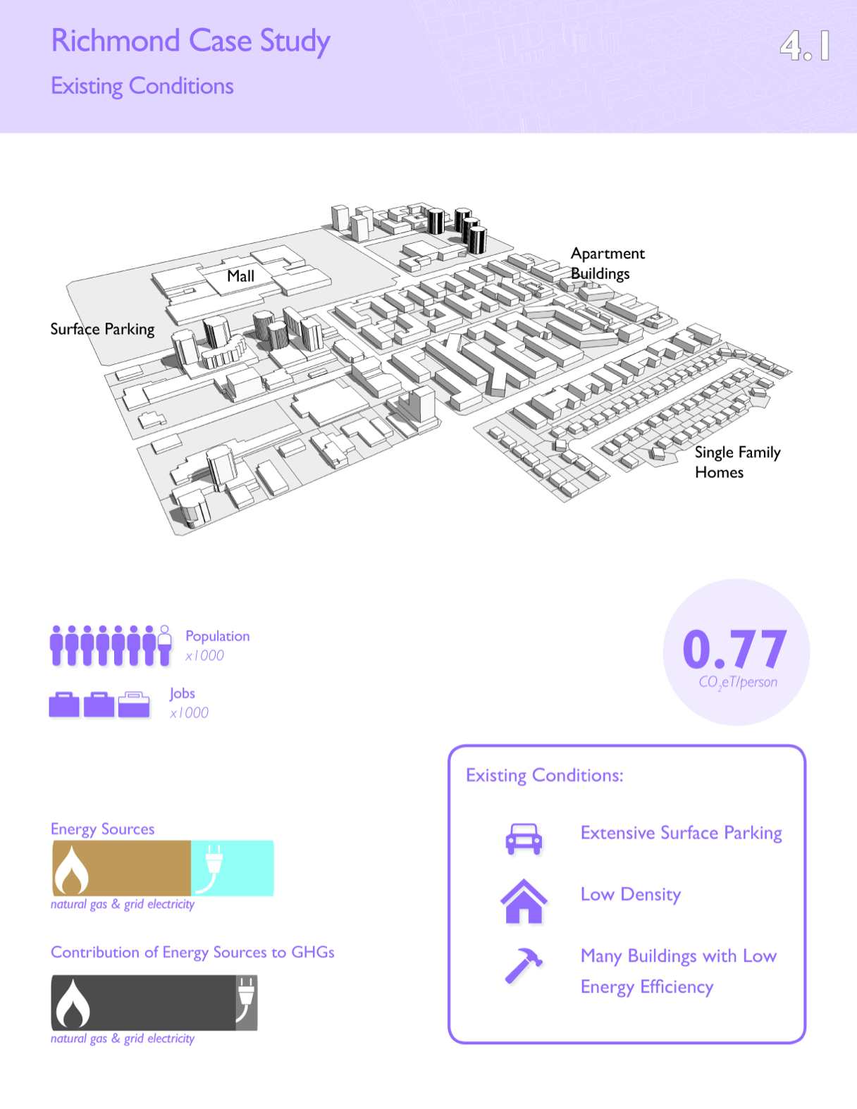

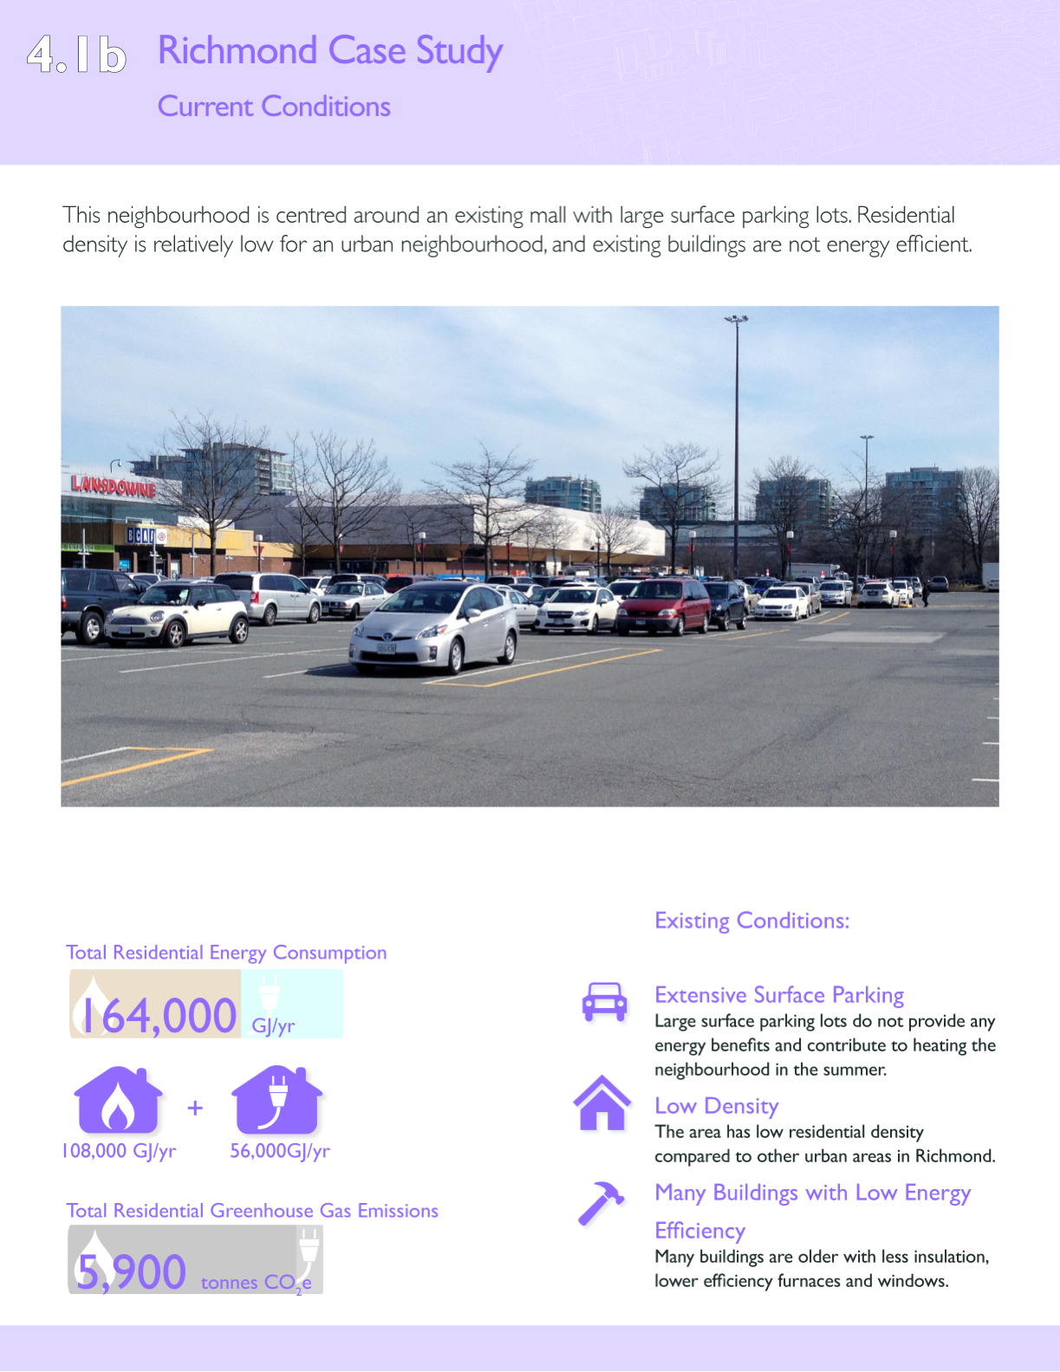

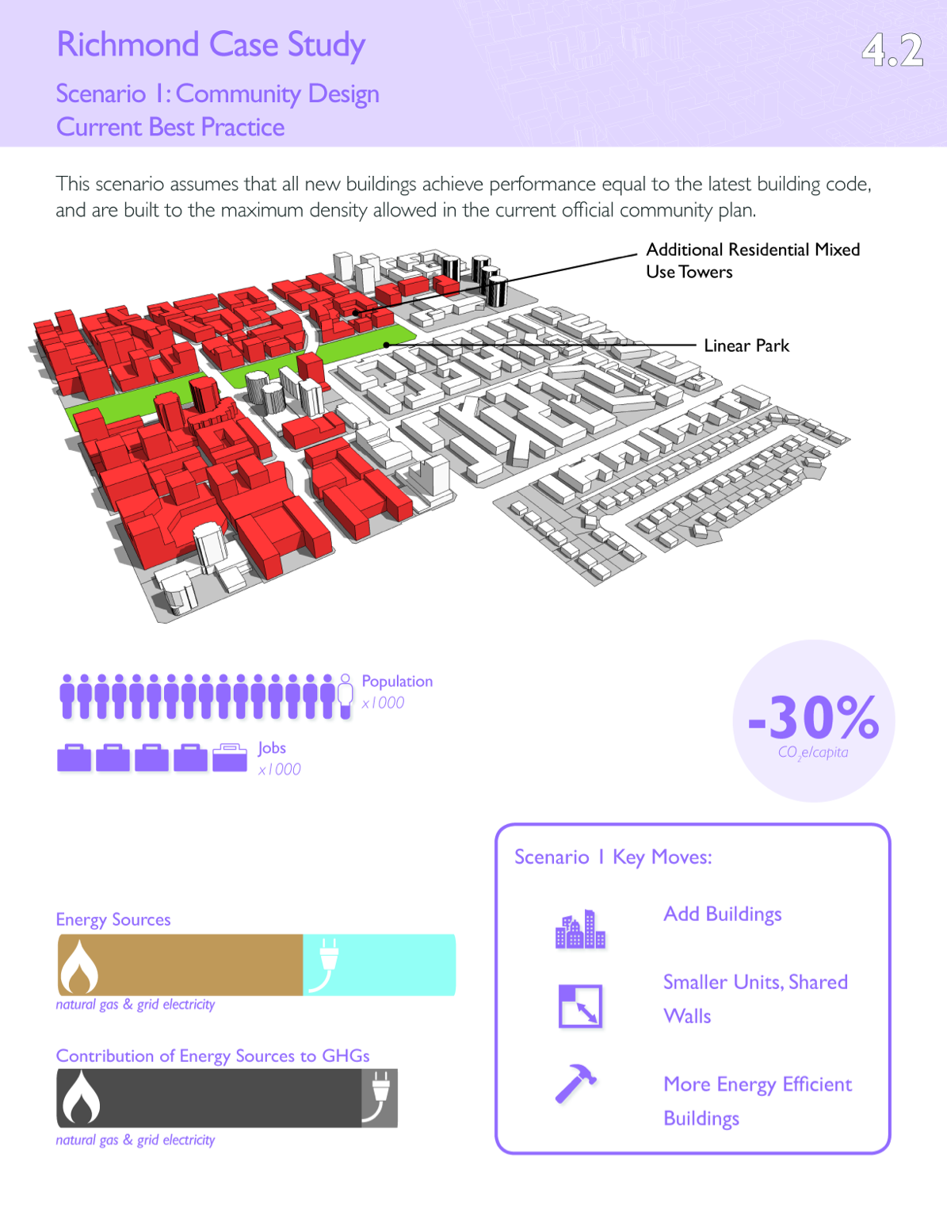

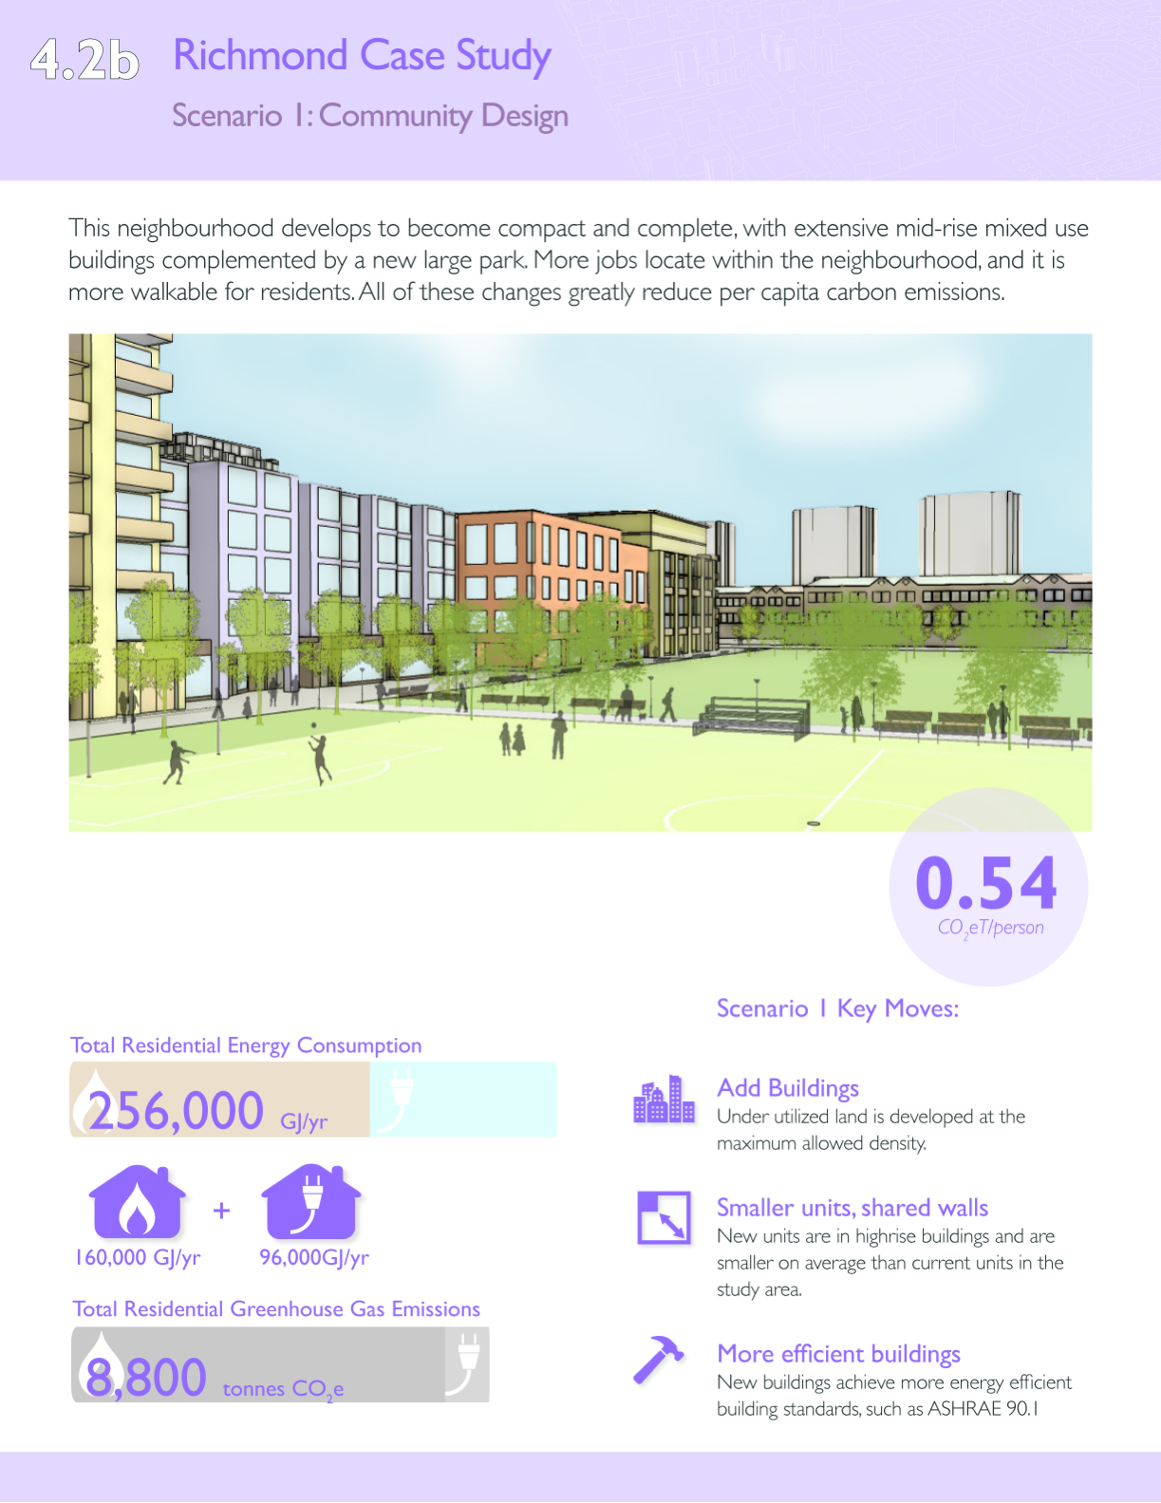

1. ,2 These action items that we heard in our interviews are potential further opportunities but with the current scope and time of the project, CALP is unable to include these items into this funding cycle. [↑](#footnote-ref-1)
2. [↑](#footnote-ref-2)
3. ,4,5 These action items that we heard in our interviews are potential further opportunities but with the current scope and time of the project, CALP is unable to include these items into this funding cycle. [↑](#footnote-ref-3)
4. [↑](#footnote-ref-4)
5. [↑](#footnote-ref-5)
6. 6, 7, 8, 9 These action items that we heard in our interviews are potential further opportunities but with the current scope and time of the project, CALP is unable to include these items into this funding cycle. [↑](#footnote-ref-6)
7. [↑](#footnote-ref-7)
8. [↑](#footnote-ref-8)
9. 9, 10, 11, 12 These action items that we heard in our interviews are potential further opportunities but with the current scope and time of the project, CALP is unable to include these items into this funding cycle. [↑](#footnote-ref-9)